Hbase to Flume Data Sink
-start hbase services
-check the service
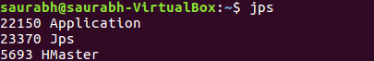

-create hbase.conf file
# Name the components on this agent
Agent1.sources = netcat-source
Agent1.channels = memory-channel
Agent1.sinks = logger-sink

# Describe/configure Source
Agent1.sources.netcat-source.type = netcat
Agent1.sources.netcat-source.bind = localhost
Agent1.sources.netcat-source.port = 44444

# Describe the sink
Agent1.sinks.logger-sink.type = logger
Agent1.sinks.logger-sink.type=hbase
Agent1.sinks.logger-sink.table=test
Agent1.sinks.logger-sink.columnFamily=CF1
Agent1.sinks.logger-sink.type=org.apache.flume.sink.hbase.AsyncHBaseSink
#Agent1.sinks.logger-sink.serializer=org.apache.flume.sink.hbase.SimpleHbaseEventSerializer

# Use a channel which buffers events in memory
Agent1.channels.memory-channel.type = memory
Agent1.channels.memory-channel.capacity = 1000
Agent1.channels.memory-channel.transactionCapacity = 100

# Bind the source and sink to the channel
Agent1.sources.netcat-source.channels = memory-channel
Agent1.sinks.logger-sink.channel = memory-channel

-open hbase shell
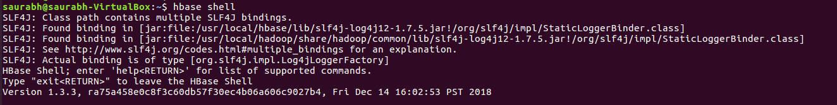
-create table in hbase
### table and column-family name should be same as .conf file
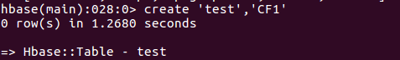

-list the table
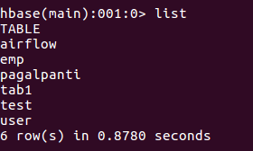

-open another terminal using this cmd.
ctrl+alt+t
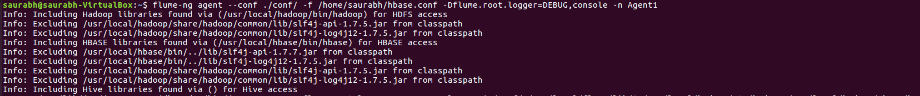
write the flume cmd
flume-ng agent --conf ./conf/ -f /home/saurabh/hbase.conf -Dflume.root.logger=DEBUG,console -n Agent1

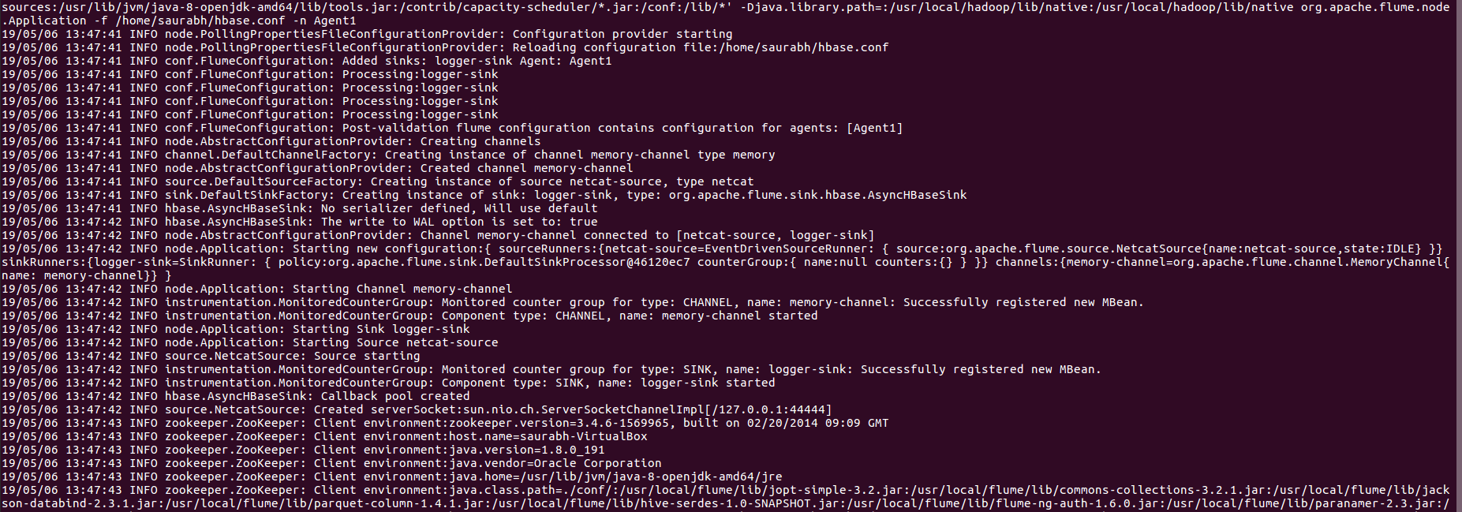
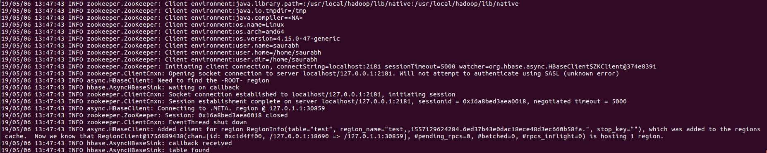
open another terminal using this cmd
ctrl+alt+t
and type
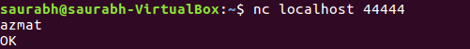

-switch the terminal where the hbase terminal open and enter
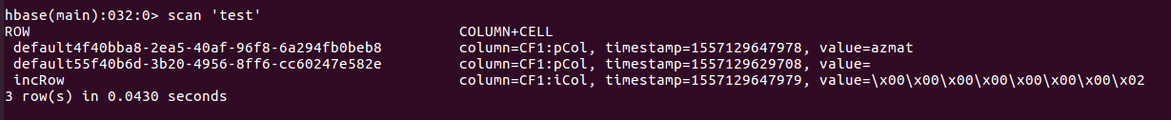
insert the data

we can insert continously data
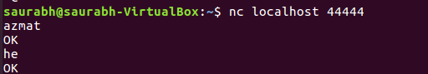

Done !

